Firas Aboushamalah

250 920 750

CS 2209 Assignment #2

Robert Mercer

QUESTION 1

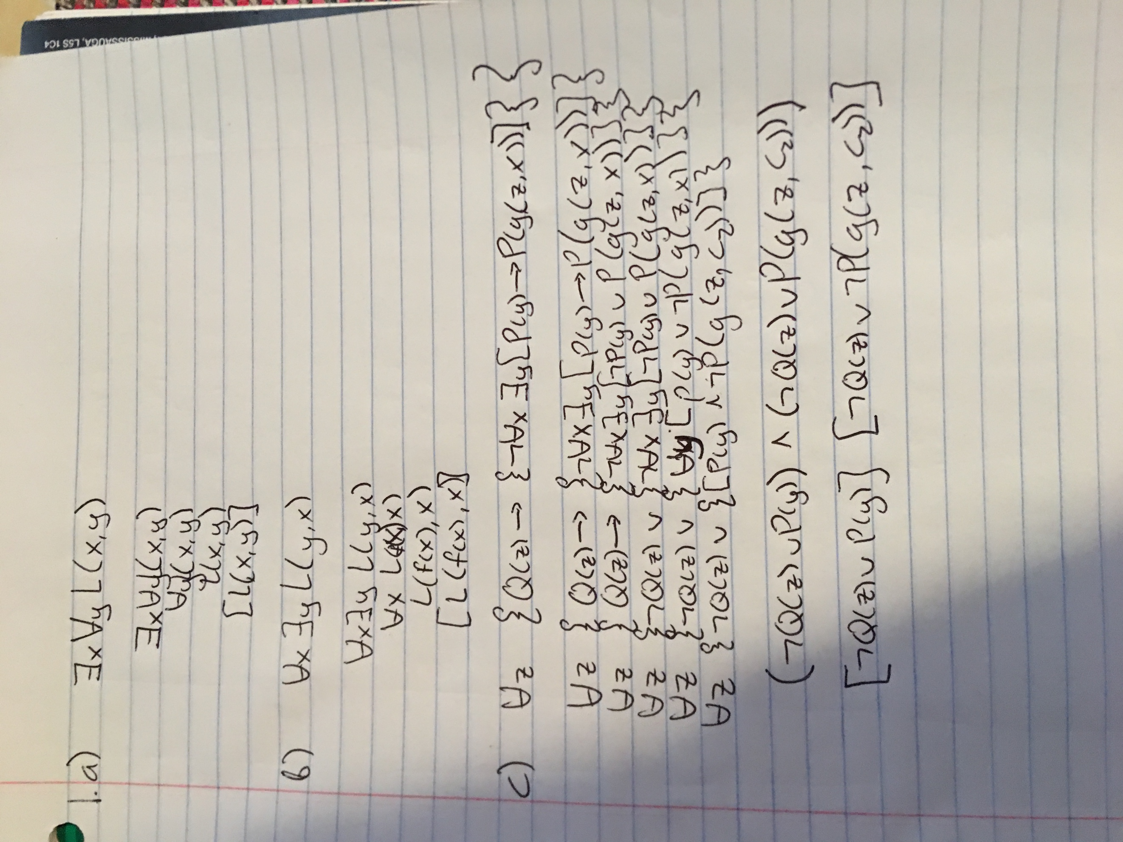

Question 2

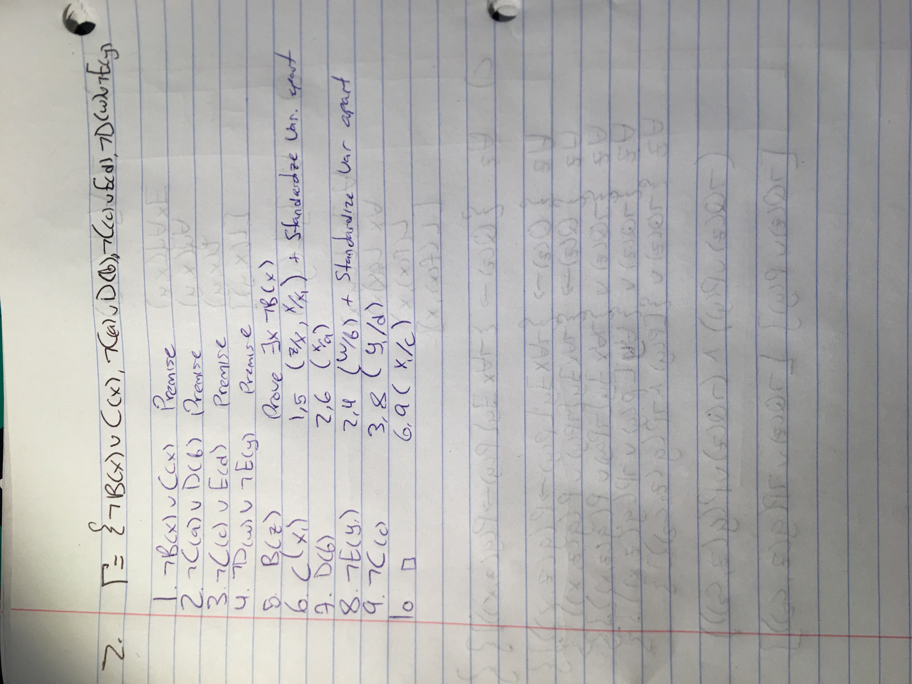

Question 3

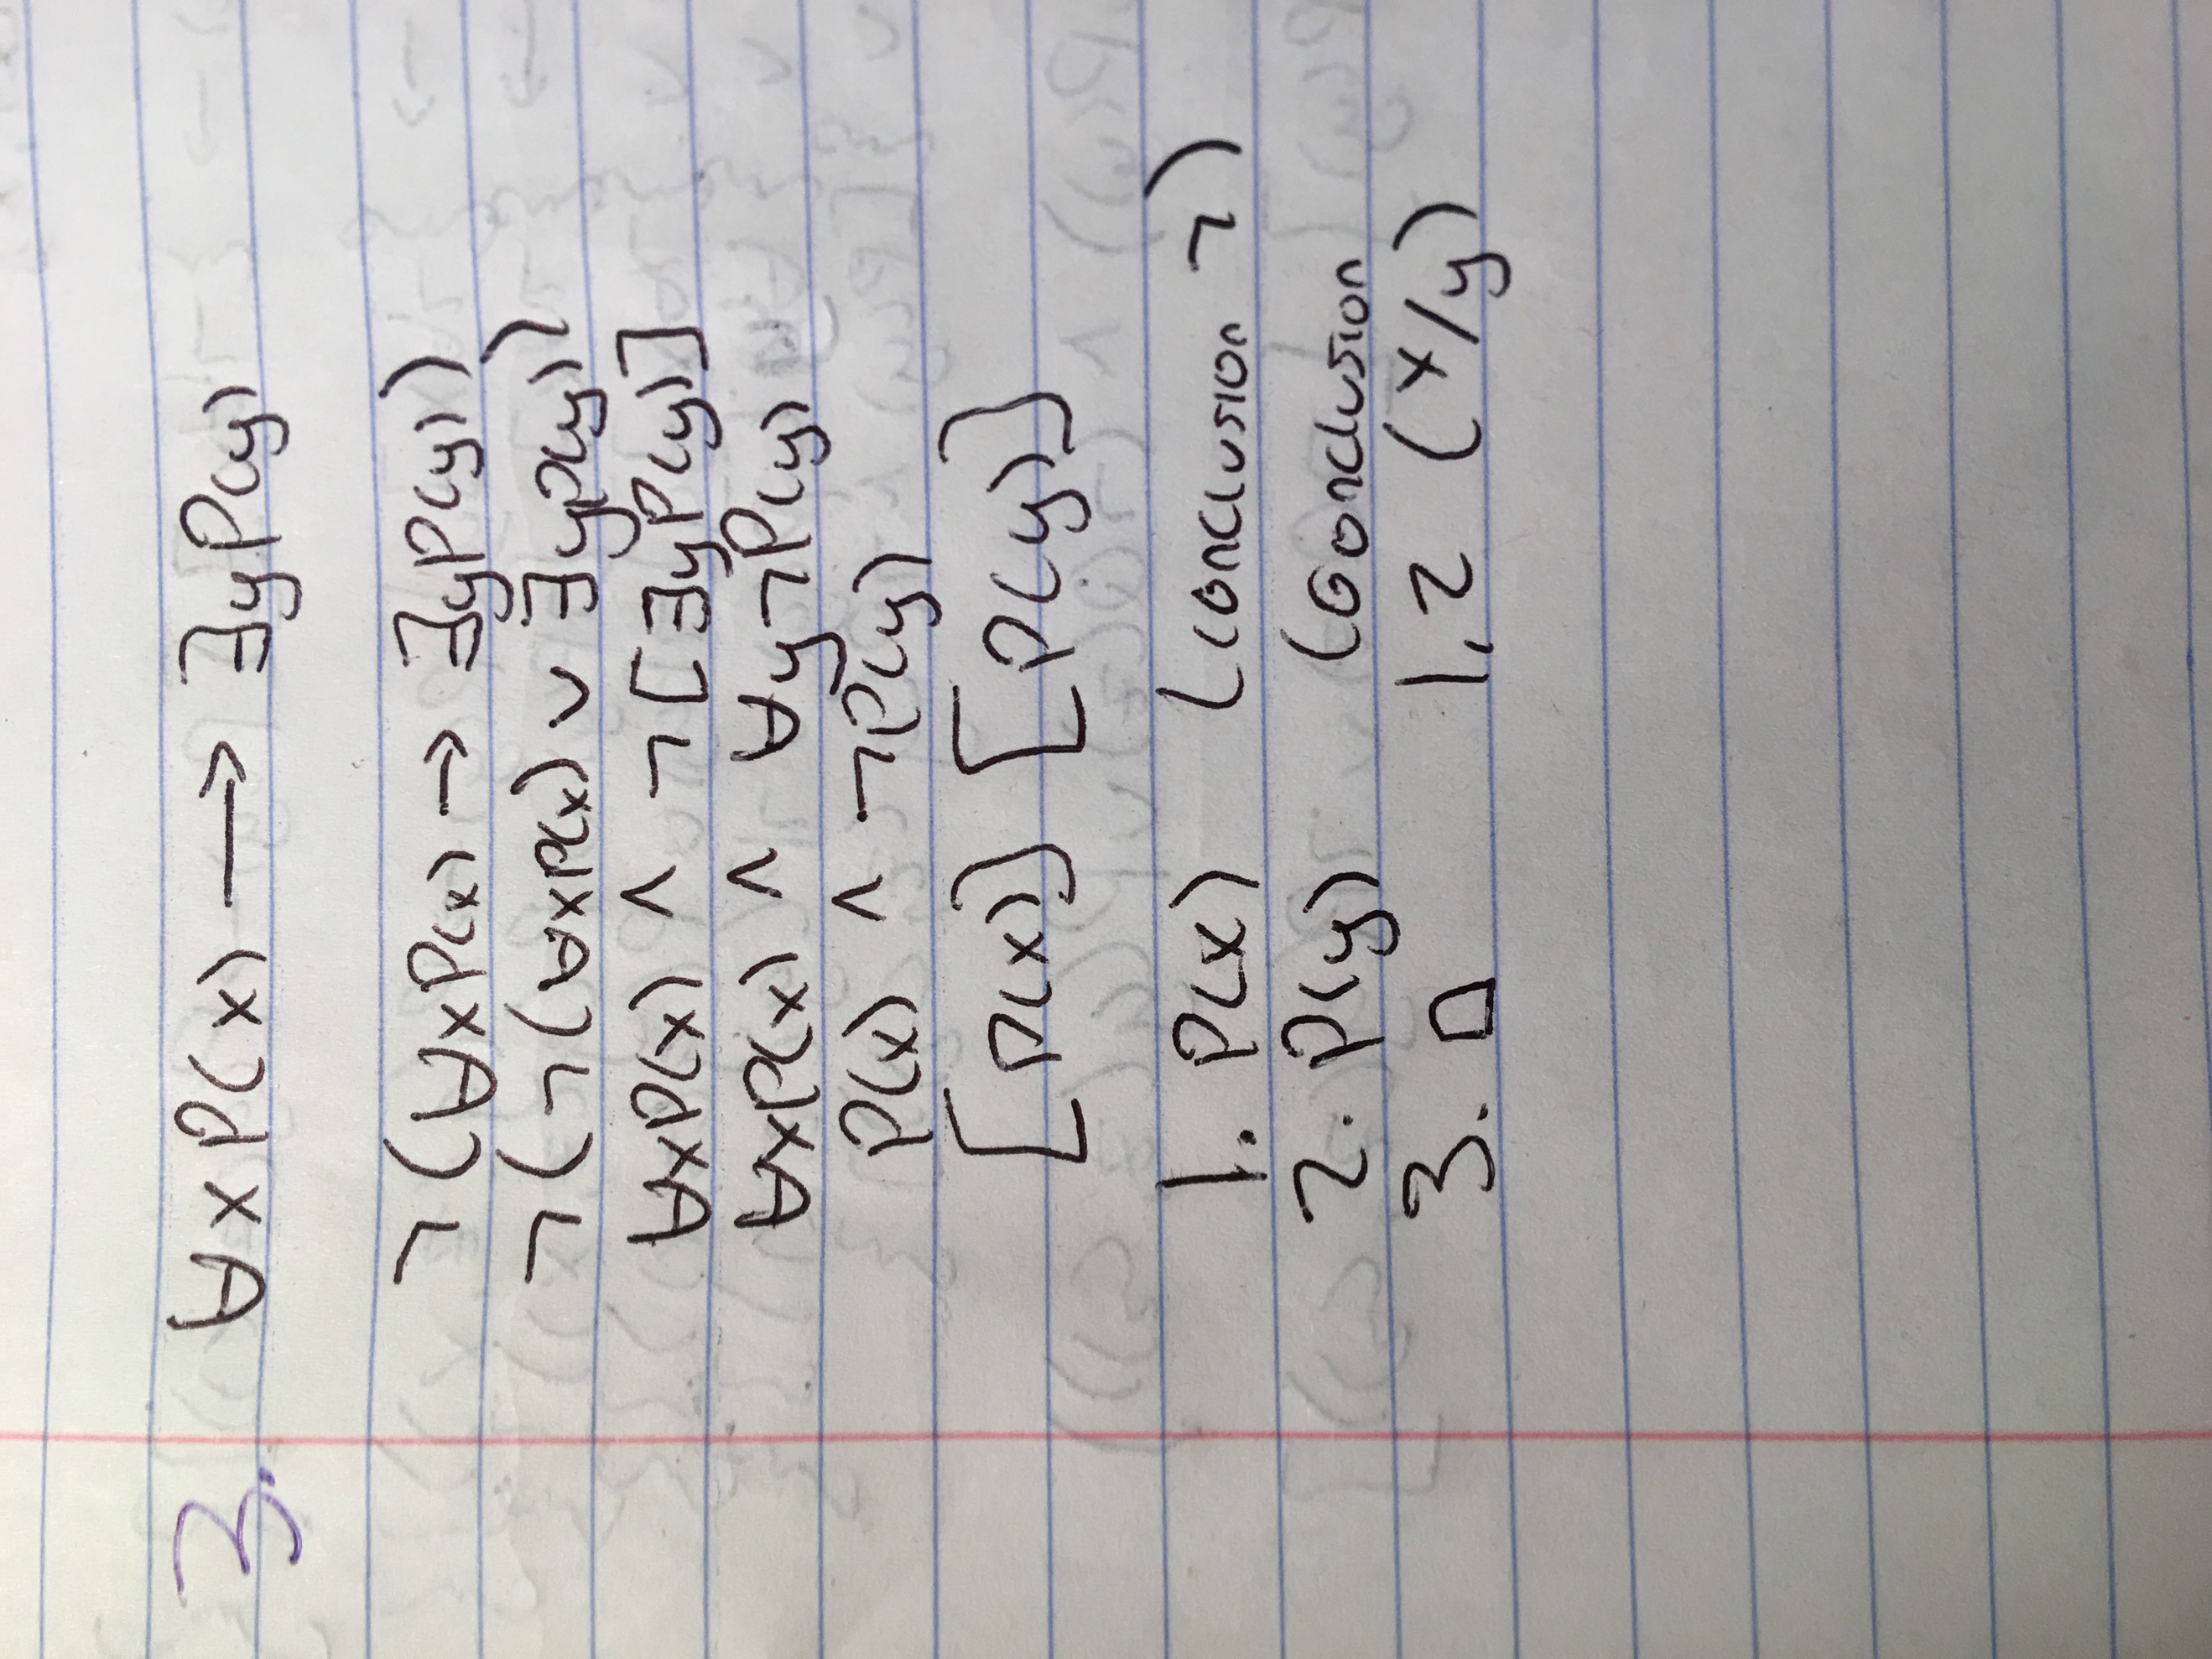

Question 4 / 5

